Title of the Practice 2: Bridge of Friendship
Goals:
· To maintain fairness among the principal, staff members (academic and administration) and the students.
· To motivate other colleagues to seek inspiration from her\his work.
· To provide a chance to express the opinion of his\her colleagues about him/her.
· To build a bond of friendship among the employees as well as the students.
To preserve memories and establish friendship with the employee forever.
· To glorify the dedication of the employees.
· To provide an opportunity for the faculty members to reveal their thoughts about the institution, colleague, work experience, challenges faced & opportunities received.
· To consider suggestions given by the employees for the progress of our college.

Context
The feeling of association and affiliation is one of the cardinal requirements for human survival, after foodstuff, accomodation, and protection. In particular, such a need is satisfied by having friends at the workplace. Workplace amity can escalate productiveness and uplift confidence. A robust bonding at the workplace will create a faculty member or a student or even a clerk to go to college with a smiling face and sound mind.
A good acquaintance at work will make a working person go to an office with a happy face and a sound mind. Comrades at the working place quench human being’s psychological requirements that are often important to display employees' best productivity. Bridge of friendship is one of the methods to discuss social issues through their personal events and incidents. Bridge of Friendship is also beneficial to stimulate educational activities. Events and achievements even at a small scale on the part of the staff as well as faculty members.

Practice / mechanism of organisation and implementation:
Dharmendrasinhji Arts College, Rajkot has formed a committee under the guidance of the Principal Dr. A. S. Rathore to organise and implement the process. To build a robust relation a unique practice runs in our college campus to enrich the knowledge of teaching and non-teaching staff. A coordinator has been appointed. The coordinator Mr. Aswin Punjani is assisted by another academician Dr. Jignesh Upadhyay. They are asked the responsibility to gather necessary details of the employee who is going to retire or have transferred to another college. Both of them together search photos, information of family background, experience, achievements, and awards of the employee. They also organise various programmes to make students' college life memorable. Students who won several competitions are appreciated by certificates. Rankers are motivated in the academic field by providing them medals and awards. Staff members are asked to reveal their feelings for the undergraduate students or the person who got the transfer or is about to start his retired life.They ask other employees to write articles and maintain the record. In this Dharmendrasinhji Arts College, Rajkot cherishes the memories and the moments spent with the person who is going away in coming days and will take send off from us. This is how our college offers our best wishes for his/her future life.
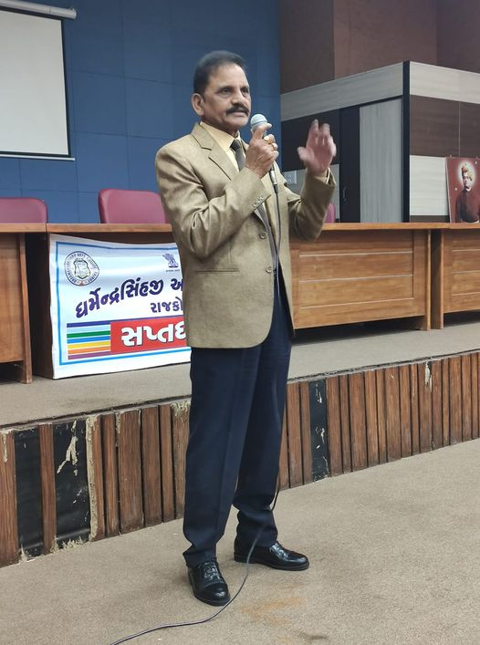
Dr. A.S Rathore- The founder of the Bridge of Friendship

Evidence of success/ beneficiaries:
The sound and the healthy bond has been noticed in our college due to this best practice. People(Students and employees) who studied or worked in this college are always helpful even after their graduation or working period respectively. Some of them spare their time for the welfare of the college. Alumni visit our college and provide certain beneficial guidelines to our current students. They become the examples of successful personalities in our society. Our undergraduates are truly encouraged by their valuable guidelines.Some of the faculties who worked in our college are also helpful to solve several issues in our college. Our Principal Dr. A. S. Rathore is the key person to sustain and maintain this concept. Our Principal has always been the mentor of not only the students but also the entire college staff. He is the captain of the ship of Friendship Bridge. Moreover, senior faculties are ready to guide the freshers, senior students always solve the doubts of junior students. In a nutshell, one can witness a wholesome harmony among all the members of our college.
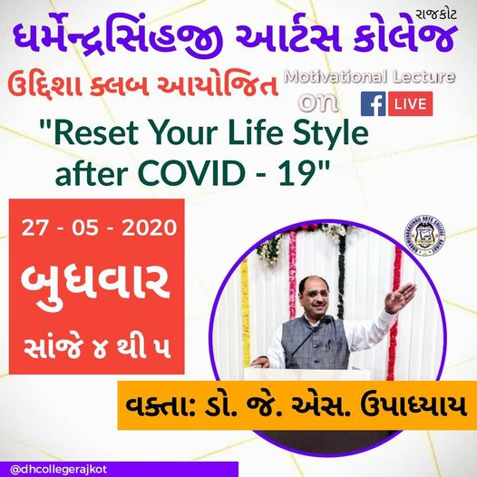
Motivational Lecture by Dr. J. S. Upadhyay for the all the students and faculty members to face the online teaching-learning system for the coming term
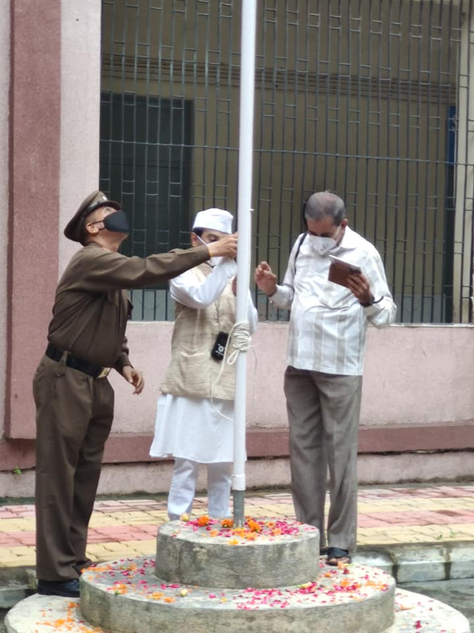
Uttam Maru(Specially Abled Sem-3 student ) was motivated to hoist the flag on
15/08/2020
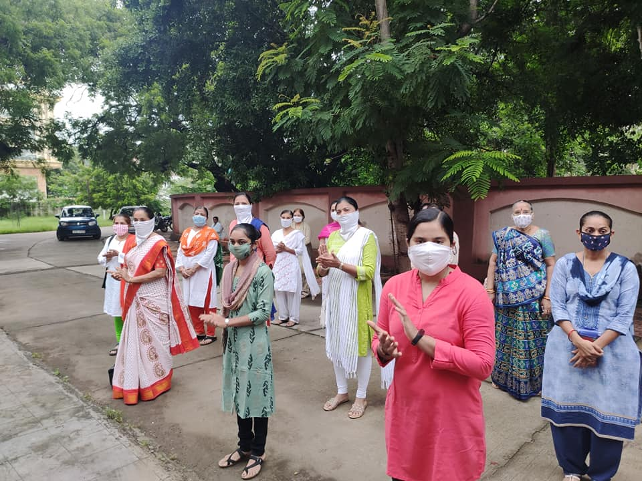
Celebration of Freedom with the bridge of friendship on 15/08/2020
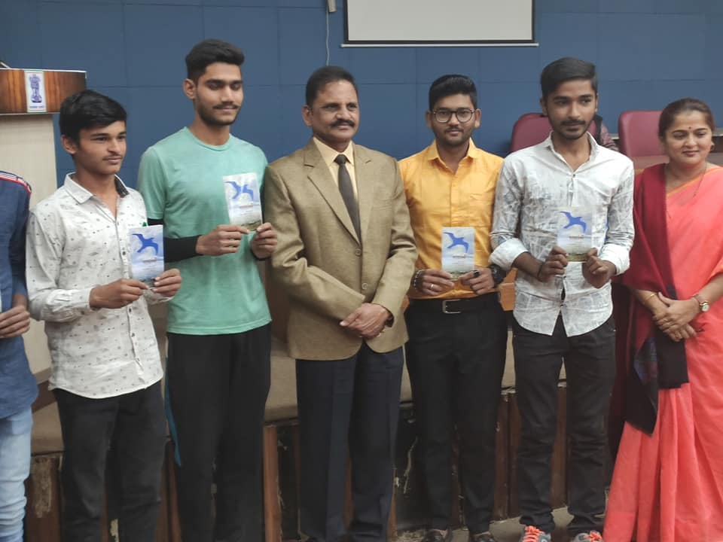
After lockdown Dr. A. S. Rathore’s interaction with students & other faculty member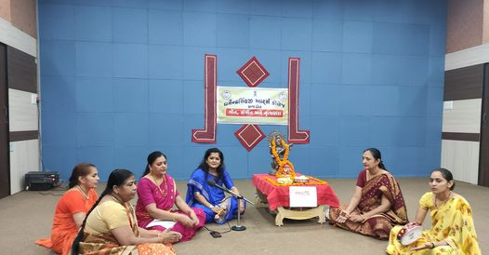
Bridge of Friendship among the faculty members -celebrating Navratri on 24/10/2020
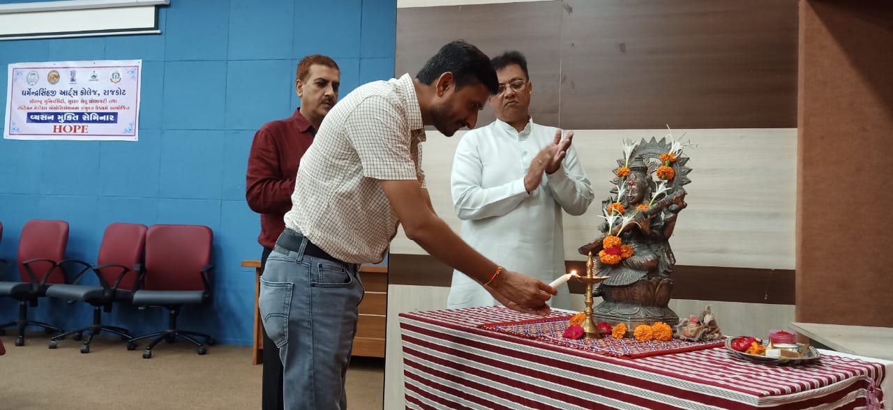
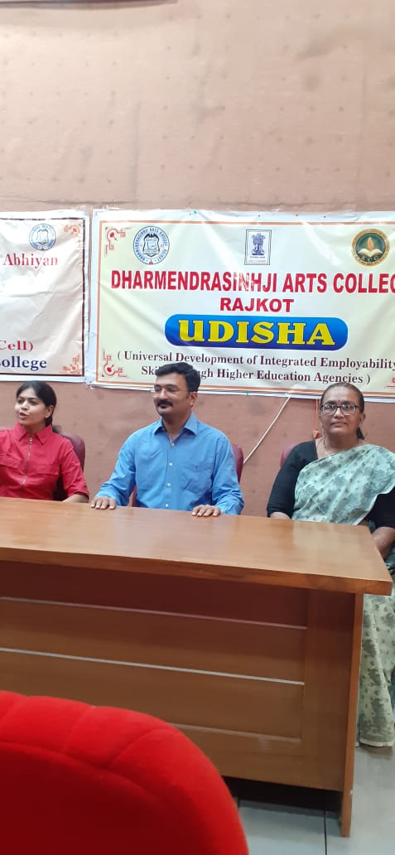
Alumni of our college were invited to deliver lectures

Problems encountered & resources required:
Alumni who work in the private sector or living out of Rajkot city can not visit the college on regular days. Therefore, they are unable to remain present in many events at our college. Besides the college is willing to provide financial aid for their extra lectures on career counselling sessions but unable to fulfil this due to lack of resources. However, the college is very optimistic to solve this matter as soon as possible.

